Jenkins Postman FastAPI

Fast API code
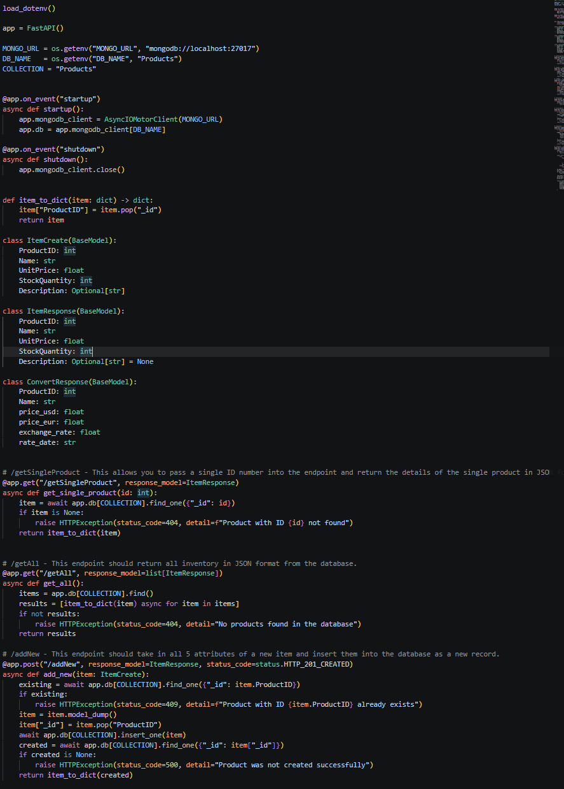
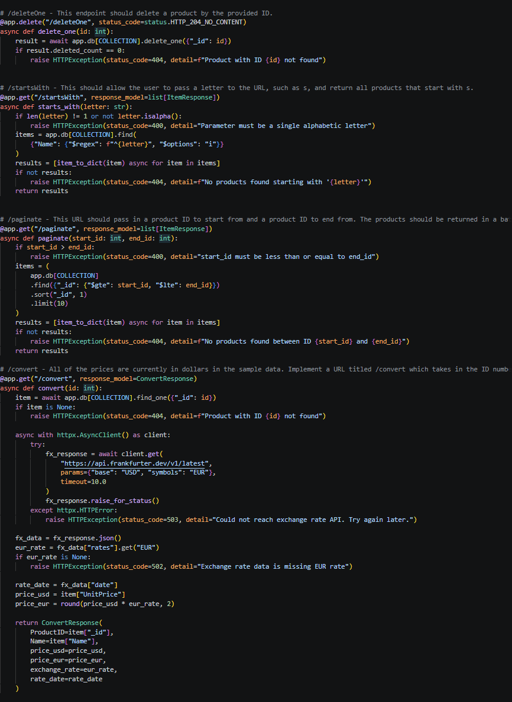

Unit test code

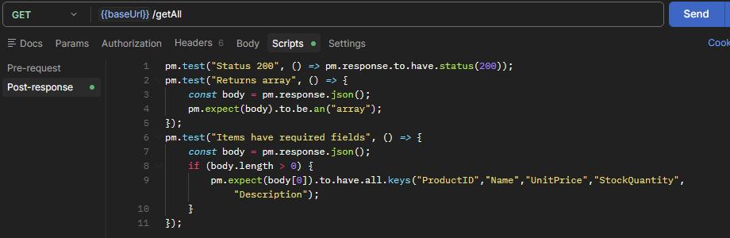
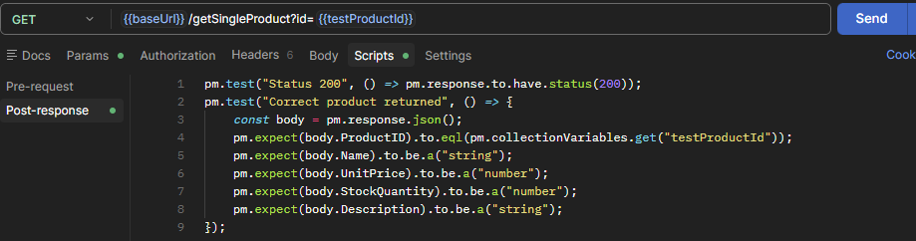
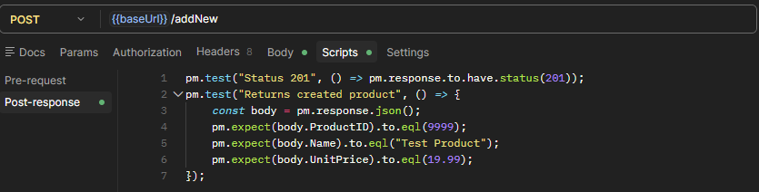
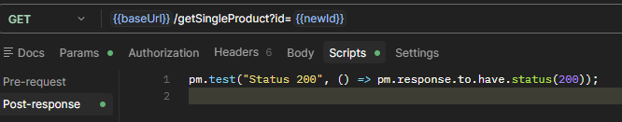
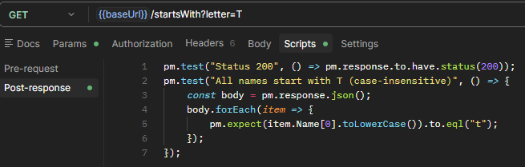
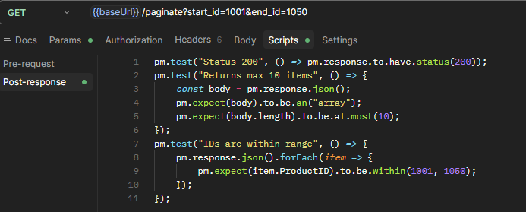
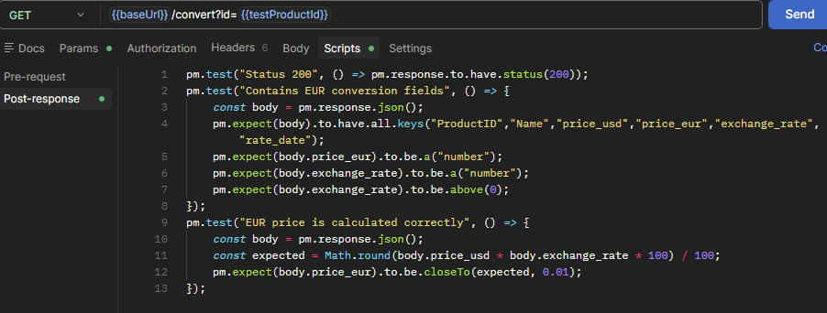
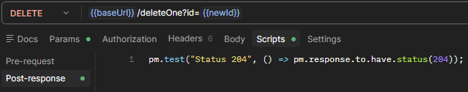
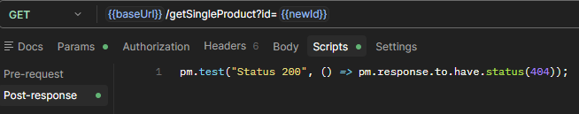

Docker config file
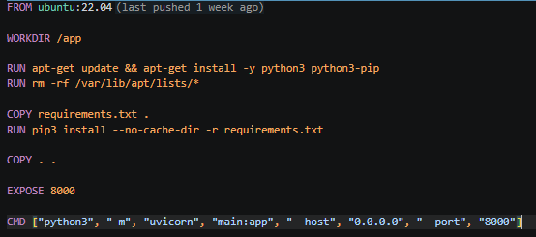

API endpoints
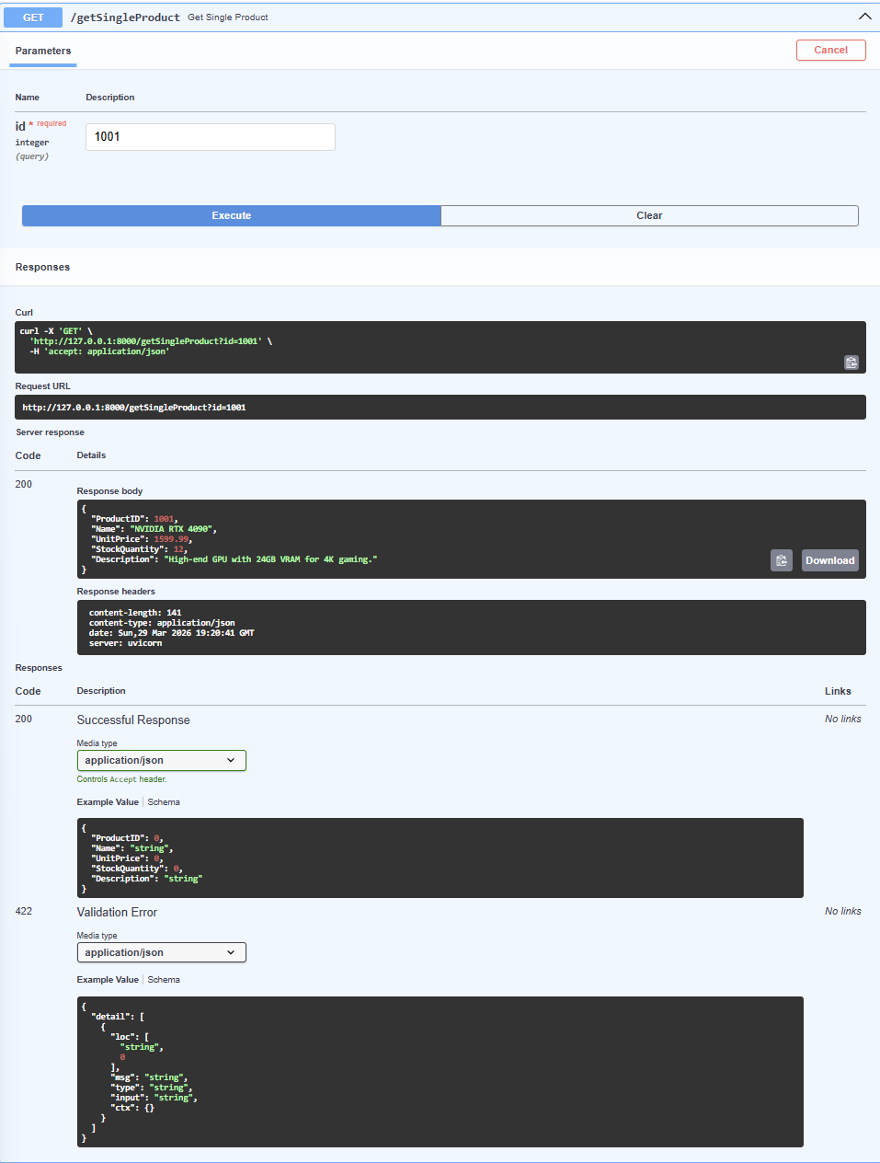
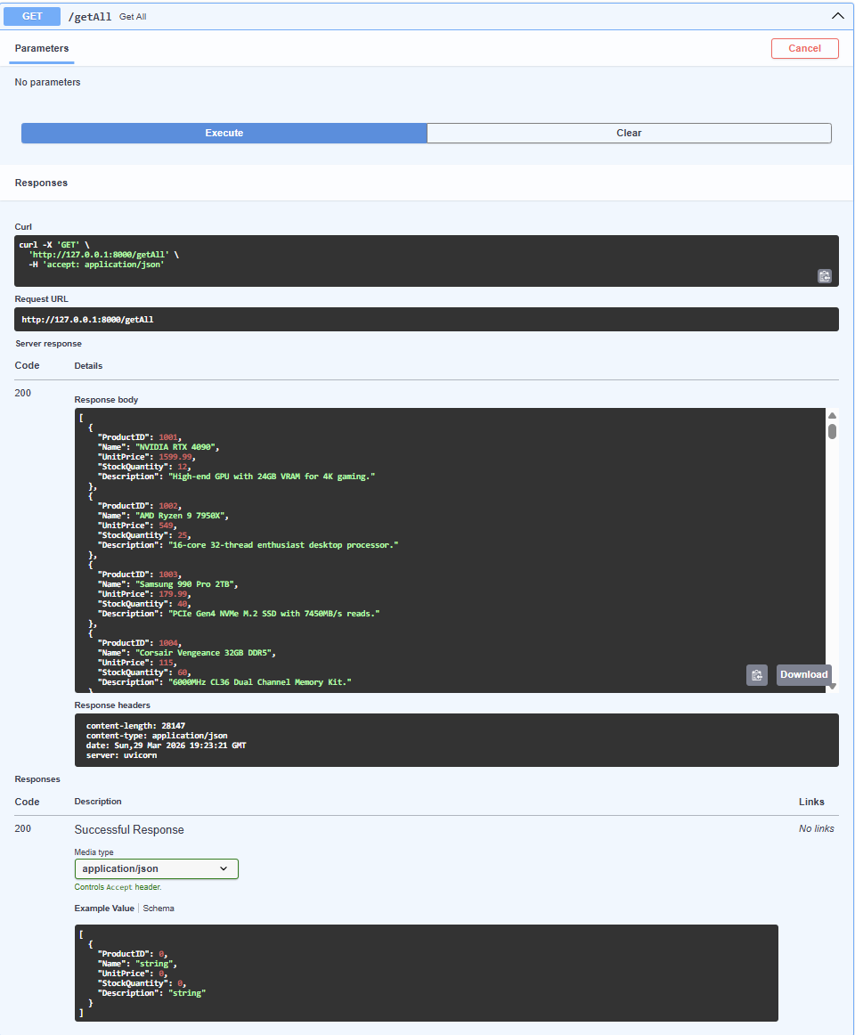

/addNew
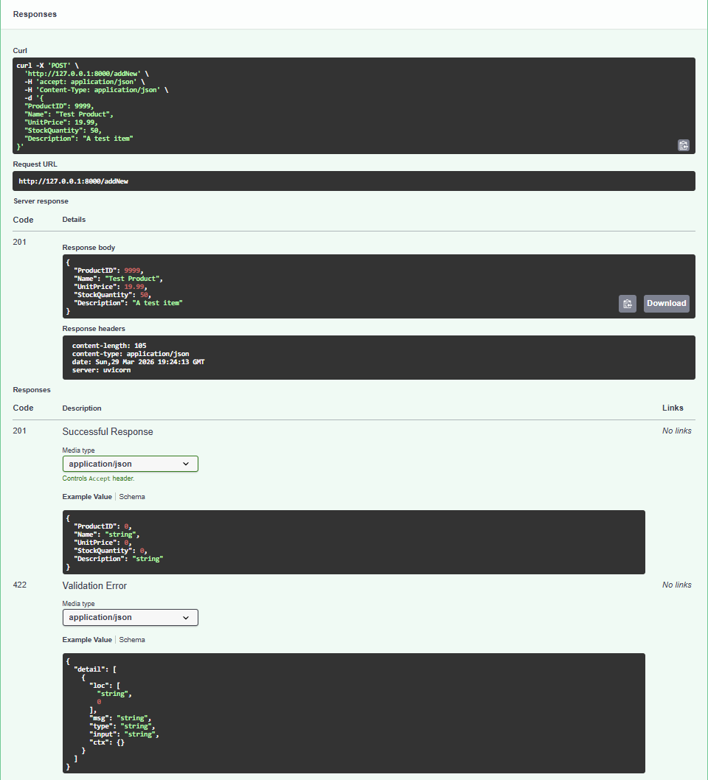
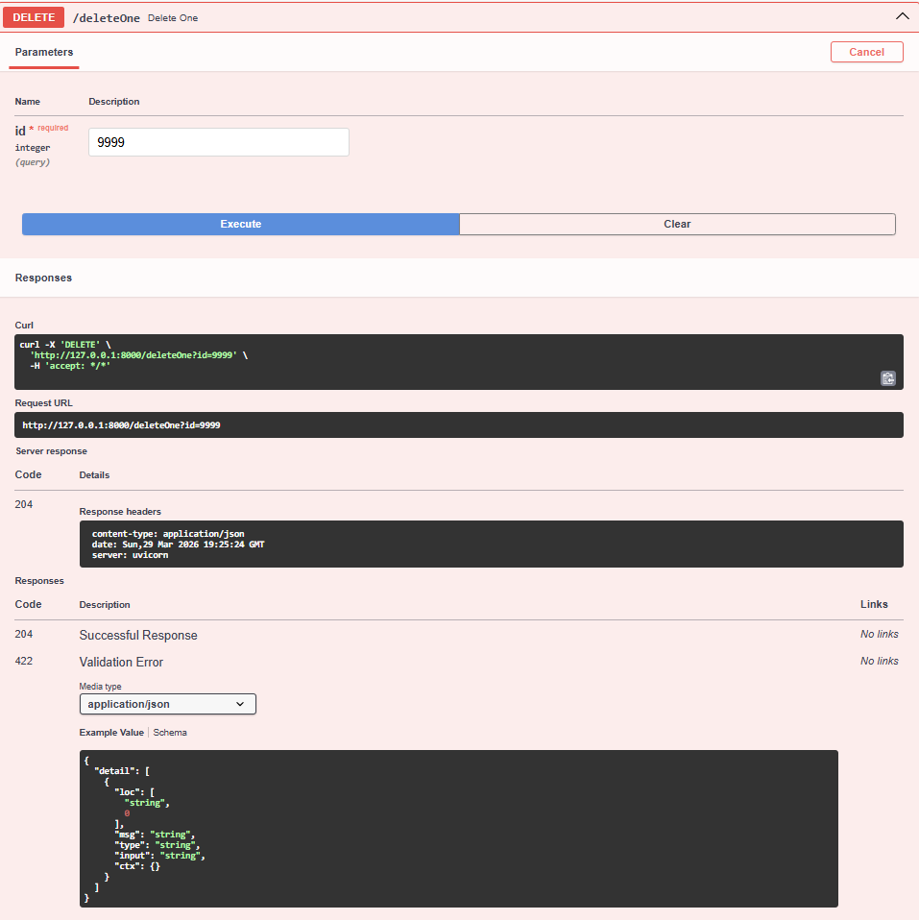

/startsWith
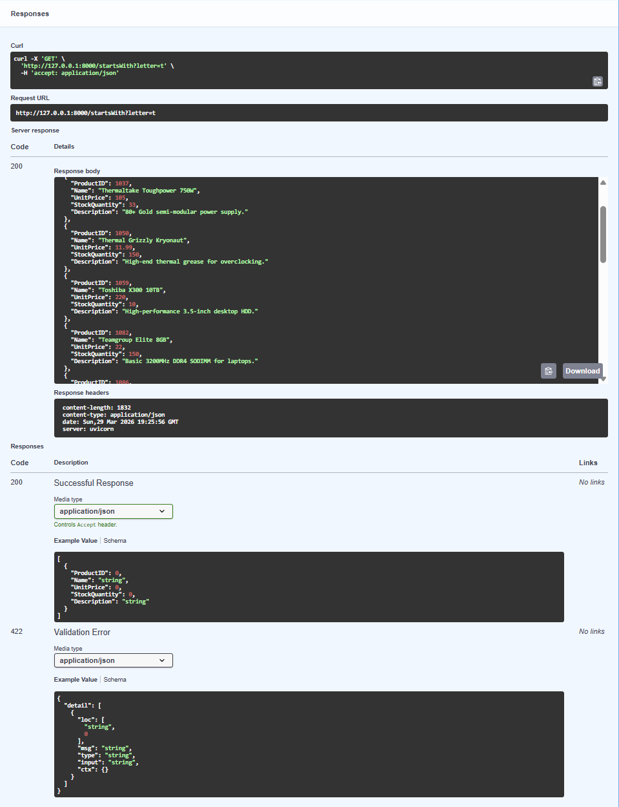

/paginate
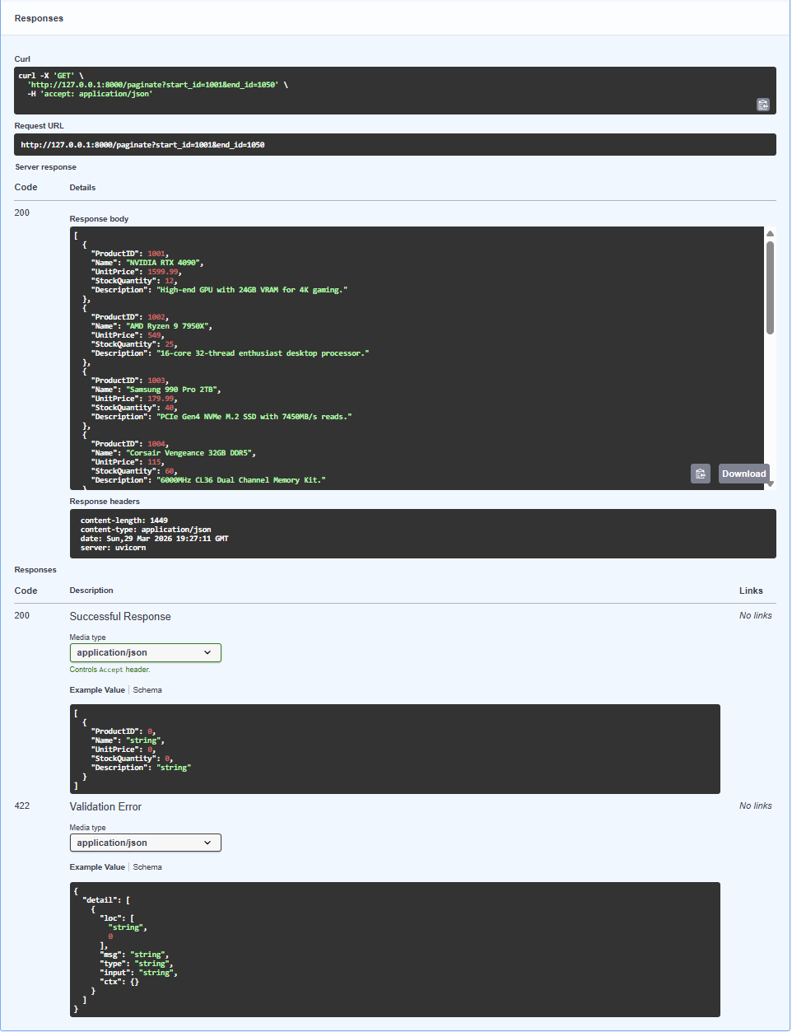
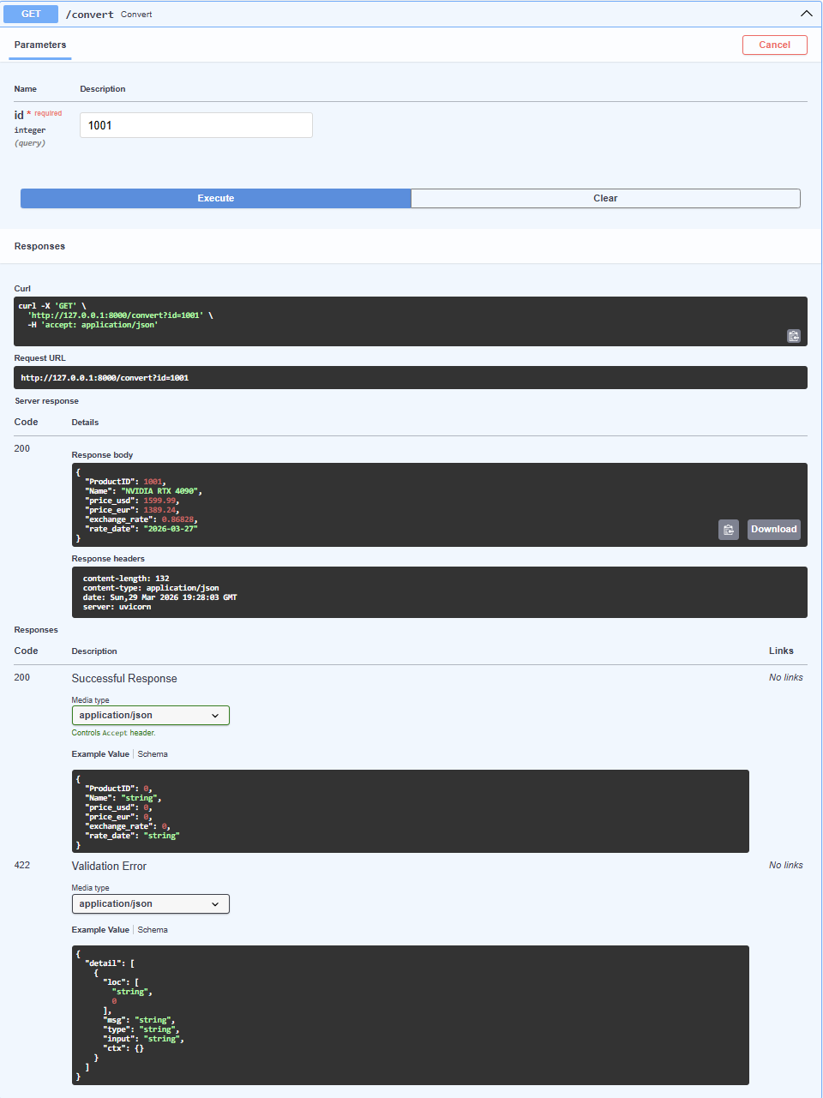
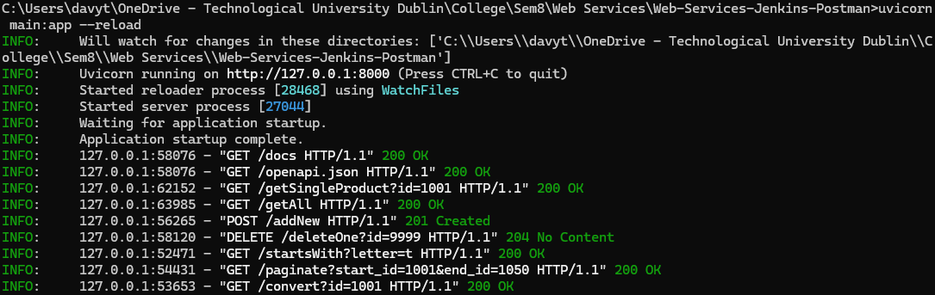

Jenkins
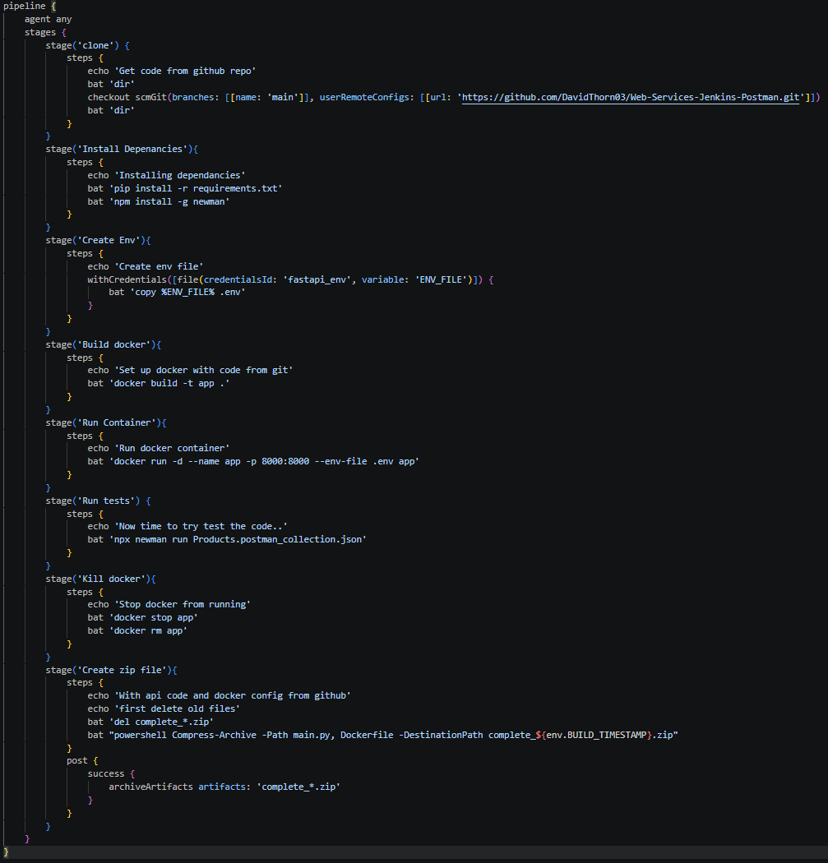

Zip file output
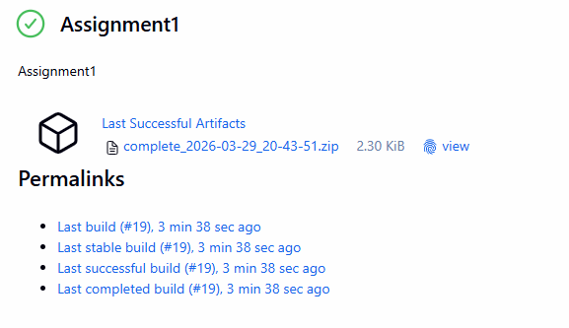
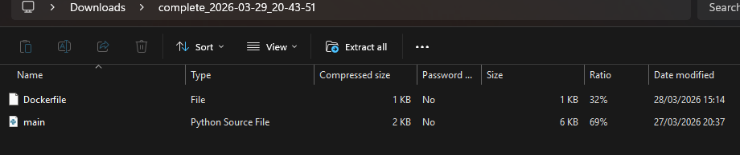

Monitoring tools
For monitoring tools I used several Jenkins plugin, which were used to more easily monitor test and build results, as well as show machine information like memory and cpu usage.

For memory and CPU usage I used the Monitoring plugin, which uses JavaMelody to get information on memory and cpu usage, the number of running build and builds in the queue.
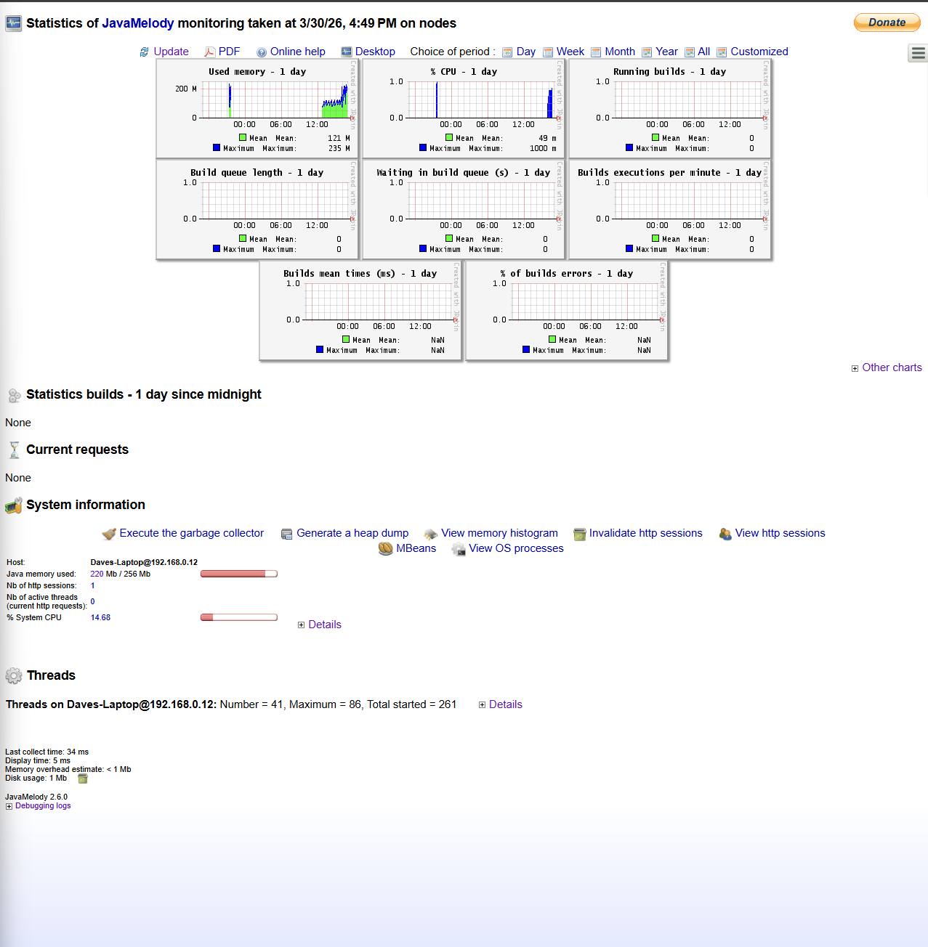

Next, the Dashboard view was used to monitor build statistics and test results. It can also be used to monitor other aspects like job statistics. It can also be used to further customize the main page view to show more information about each of the pipelines, like the git branches it is using.
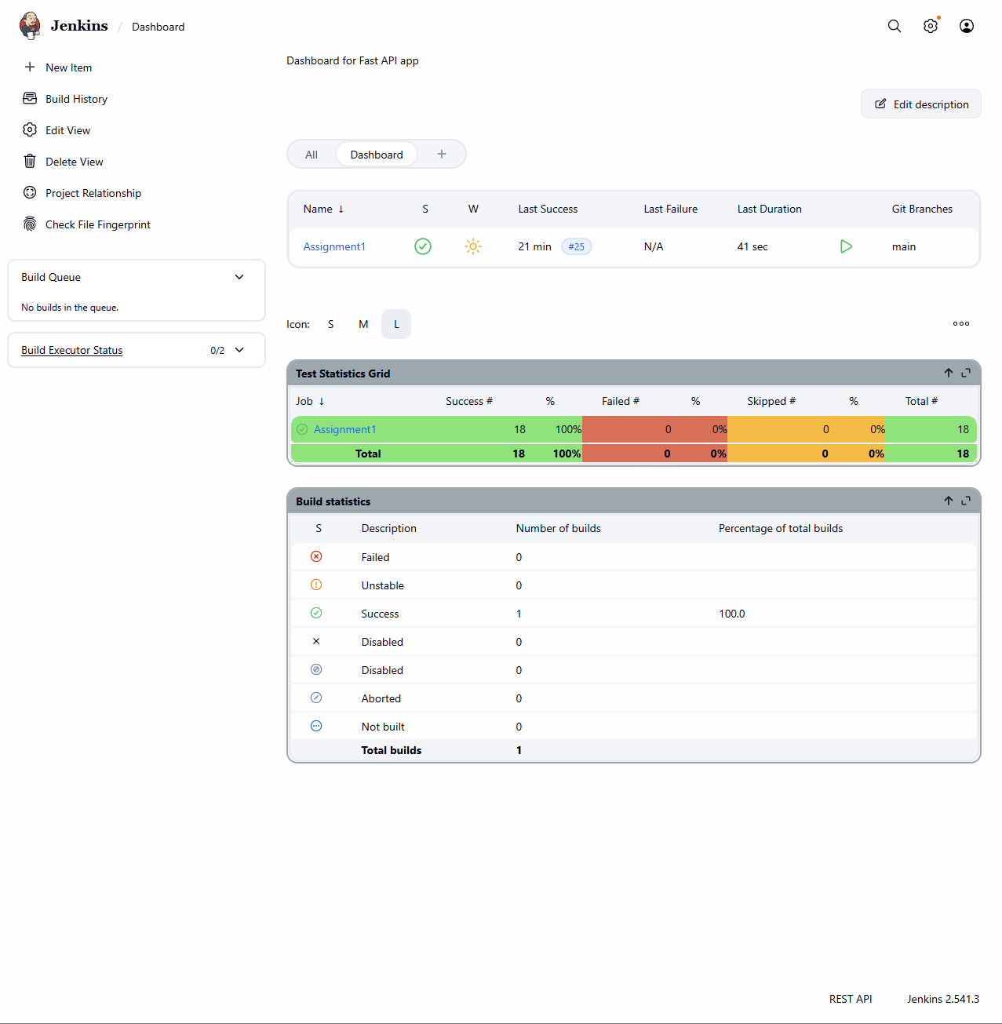
NOTE: To get the test statistics seen here, new lines need to be added to the test stage of the pipeline.
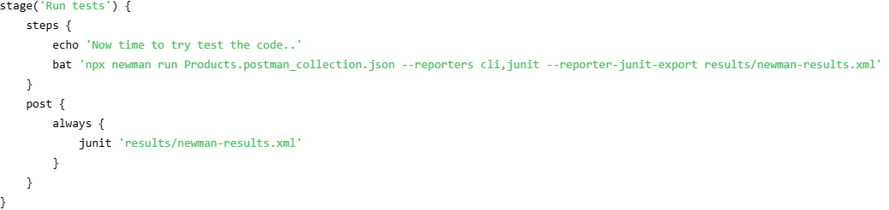

Finally, the job and stage monitoring plugin was used. This allows you to more clearly see how jobs perform on a stage by stage level. You can use this both to compare the results of several previous jobs and job specific results.
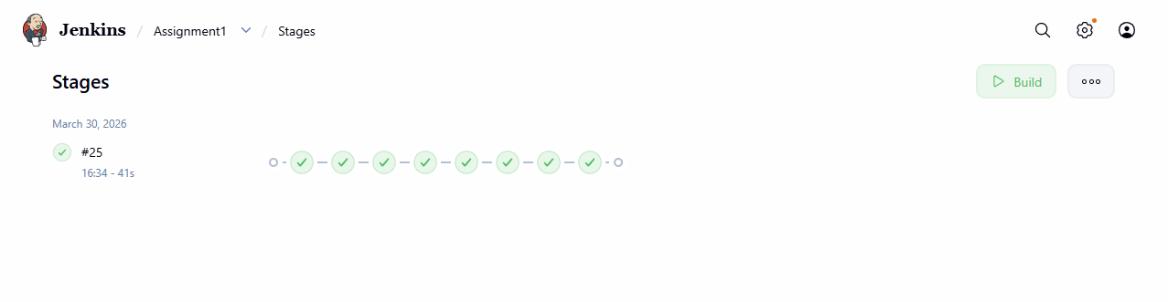
Note: There would be more jobs shown here, the pipeline used here only saves the most recent successful job and hence, only one is shown.
This plugin makes it easier to see not just stage by stage, but line by line results.
